**University of Sunderland**



**Faculty of Technology**

**Pre-Applicant Day Activity**

**Introduction**

Thank you for choosing the University of Sunderland and the Faculty of Technology as a place to study your chosen degree. We are very excited to welcome you and hope to see you at the upcoming Applicant Experience Day.

You will have received a welcome pack with some interesting items, including a small micro-computer, small OLED screen and special sensor (temperature and humidity). We are going to use these items to build and program the basics of an Internet of Things Weather Station.

Within your pack you should have received the following:

Figure 1 – Components of Weather Station

The Raspberry Pi Pico is a very small micro computer that we can program using Python (more on that soon) and connect various sensors to. Below is a reference image that we will refer to later on:

Figure 2 – Pinouts of Raspberry Pi Pico

**Software installation**

Before we start, there is some software we need to install. You need to install a Micro Python editor called Thonny. This is free and is available for Windows, Linux and Mac. Go to the following URL: <https://thonny.org/> download and install the software. When this is complete you can open Thonny.

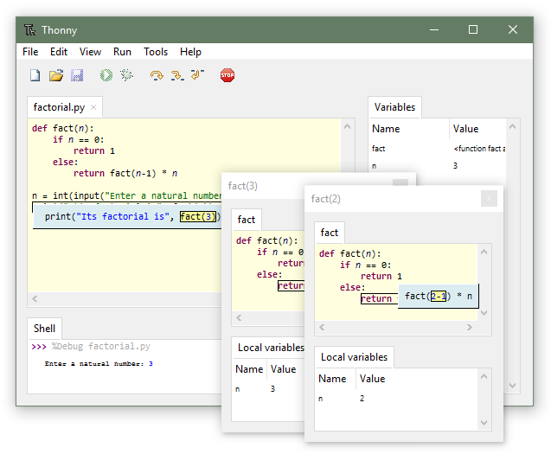

Figure 3 – Thonny Software

Now, connect your Raspberry Pi Pico to your computer using the supplied USB cable. Then click on the red ‘Stop/Restart Backend’ button on the toolbar and you should see (if not, refer to Troubleshooting Tip 1 at the end of this worksheet):

Figure 4 – Detecting the micro-computer

**Coding the micro computer**

You will find all the code and some further help and instruction on our GitHub page: <https://github.com/keukpa/UoS-ApplicantDay>

**OLED Screen code**

To make our screen display the information we need we have to first create some code. In Thonny, with your Raspberry Pi Pico connected. Click:

File 🡪 New

Go to the GitHub page and select the file: **ssd1306.py**, you will see all the code. Select ‘**Copy Raw Contents**’ then in your Thonny software select: Edit 🡪 Paste.

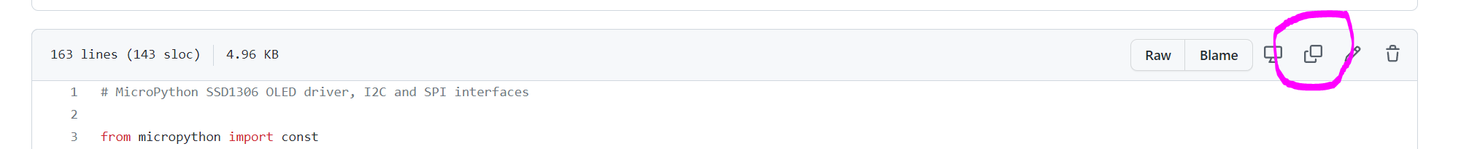

Figure 5 – Copy Raw Contents

We now need to save this to the Raspberry Pi Pico: File 🡪 Save, select ‘Raspberry Pi Pico’ and call the file: ssd1306.py. Select ‘OK’.

Figure 6 – Saving Files to the Pico

You have successfully added some code to your micro-computer.

**Coding the Sensors**

Next, we need to write some code for the Temperature and Humidity sensor so we can get some interesting data from our environment. On the GitHub page, click on the file: dht.py this is the code for the sensor. In Thonny, select: File 🡪 New, and copy and paste the code in there, again, save this to the Raspberry Pi Pico, with the name: dht.py.

We now have all the background code we need, now is time to write the main working code.

**Writing the Main code**

**Troubleshooting**

**Tip 1:** If the Thonny software doesn’t detect your Raspberry Pi Pico, then on the meu bar click:

Tools 🡪 Options 🡪 Interpreter 🡪 Port

Then select the COM port in the drop down menu.

